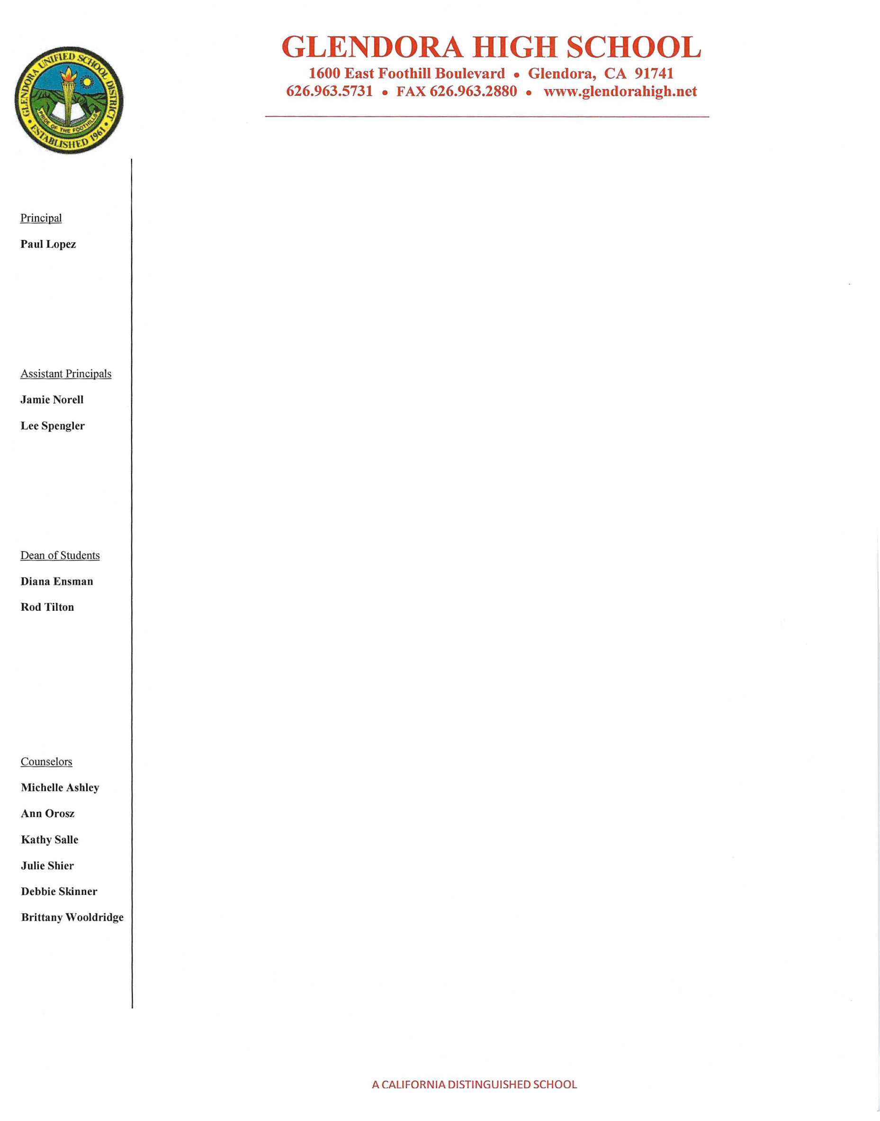
March 11, 2017

To Whom It May Concern,

It is with great pleasure and enthusiasm that I write this letter of recommendation for Mrs. Lynn Muñoz as she pursues a teaching position with your school. I have been very fortunate to work closely with Mrs. Muñoz at Glendora High School as a support aide for her Earth Science class during the 2016/2017 academic year.

As a support aide for a special needs student in her classroom, I had the unique opportunity to observe Mrs. Muñoz’s teaching methods. Her creativity in developing lesson plans to meet Common Core Standards and integrating the new NGSS practices are impeccable. Students are always her highest priority, ensuring they are engaged and involved in discussion, projects, and classwork. I have witnessed her encourage and motivate her students to be their best selves. The daily journal prompts allow students to seek truth, think critically and outside of the box.

Mrs. Muñoz is dedicated, hardworking and patient. She is always going above and beyond, using technology to create PowerPoints, creating templates for projects, updating Google Classroom, and using varied apps to help students review for quizzes, such as Kahoot. Her positive energy is contagious and makes her approachable. Students always seek her help or advice, during morning tutorials, nutrition, lunch, and after school. She is also very accommodating to the special needs of students. In fact, she has a special needs son who also attends the school providing her with a personalized perspective as both a parent and an educator. Consequently, she has the experience and patience to work with kids of all ages and abilities.

Mrs. Muñoz classroom management skills are astonishing. She is structured, organized, and firm. She uses many aspects based on the Whole Brain Teaching strategies, especially the five rules specifically designed to keep students focused and engaged. In addition, her organization flows throughout as even her classroom is color coded so students can easily find exactly what they are missing from their course colored folders.

I strongly believe that Mrs. Lynn Muñoz will be a great asset for any district she seeks employment. Her hard work and commitment allows me to stand by her and speak highly in her favor. For further information please feel free to call me at (626)622-7419.

Sincerely,

Cristina Renderos
Instructional Aide-SPED/ASD
Glendora High School

